Experiment 10 **LED CHASER USING 8051 USING KEIL AND PROTEUS**

**AIM:**

Write an assembly language program for LED Chaser Using 8051 using Keil and Proteus

**SOFTWARE REQUIRED:**

* Keil software 5.
* Proteus 8 software.

**PROCEDURE:**1.open the software ,click on project and open new version project.

2.create a new project file

3. enter AT89C51RD2

4.click no

5.click ctrl n and write code

6. open project and click target build

7. open target build and open source file and ADD, CLOSE

8. click target build

9. next debug start and stop

10.open peripherals and select port 2

11. run the program in debug

12. open project and click optional properties and in that give output as hexa file.

13. Create Hex file

**PROTEUS PROCEDURE:**

* Open proteus by clicking run as administrator.
* Open new project and enter the file name.
* Click next, next, next and finish.
* Click P symbol and search keyword and place the required components

The components required are:

* AT89C51
* Led Bar graph Red
* Crystal
* Choose terminal mode, select ground and place it two times
* Cap

* Connecting pin number 21 to 1 in Led Bargraph
* Likewise, connect pin 22, 23, 24, 25, 26, 27 & 28 to the pins 2, 3, 4, 5, 6, 7 & 8 in the Led Bargraph
* Connecting ground to the Led Bargraph(pin 20)
* Connecting pins 13, 14, 15, 16, 17, 18, 19, 20 to the ground
* Connecting pins 19 & 18 of the AT89C51 to the ends of the two capacitors
* Now, connect both the capacitors together
* Connect the ground to the Capacitors
* Connecting two ends of the Crystal
* Change the frequency of the Crystal to 16MHZ
* Change the Capacitance to 33pF
* Select the Hex file
* Start the simulation process

**PROGRAM:**

ORG 0000H

UP: MOV P2,#01H

ACALL DELAY

MOV P2,#02H

ACALL DELAY

MOV P2,#04H

ACALL DELAY

MOV P2,#08H

ACALL DELAY

MOV P2,#10H

ACALL DELAY

MOV P2,#20H

ACALL DELAY

MOV P2,#40H

ACALL DELAY

MOV P2,#80H

ACALL DELAY

SJMP UP

DELAY: MOV R4,#255

H1: DJNZ R4,H1

RET

END

Circuit Diagram:

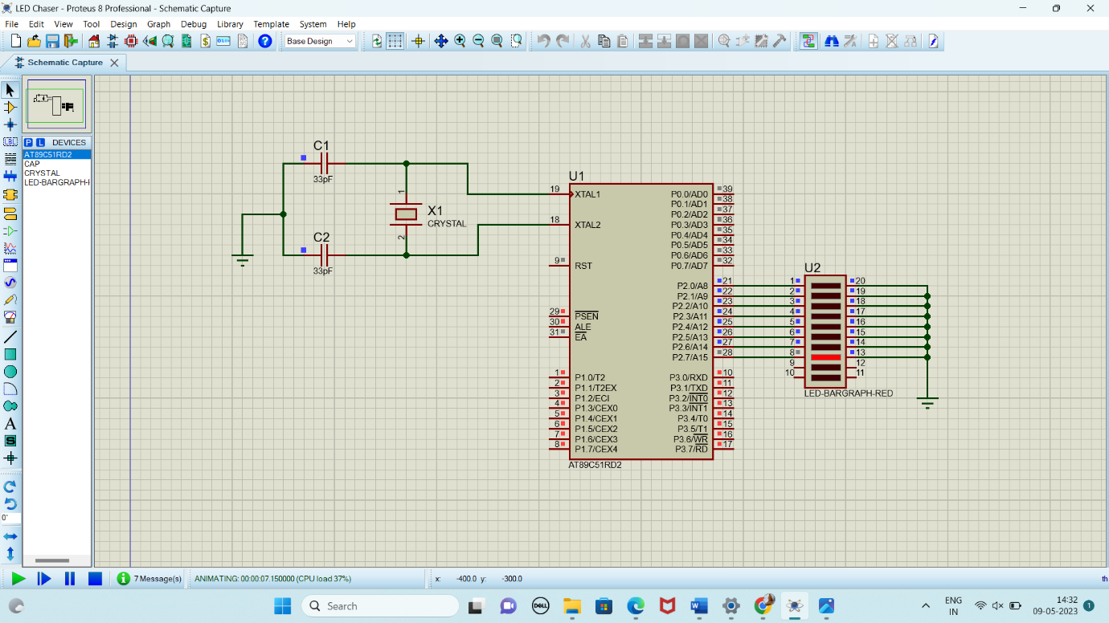

**RESULT:**

Thus the program has been successfully verified and executed.